**Part 3 - Modifying List Property Component**

We already have component for list property, so we only need to modify css, ts and html files within component.

Step 1, Please open property-list.component.ts , and type the script like below image. This array of object will be data source for card component

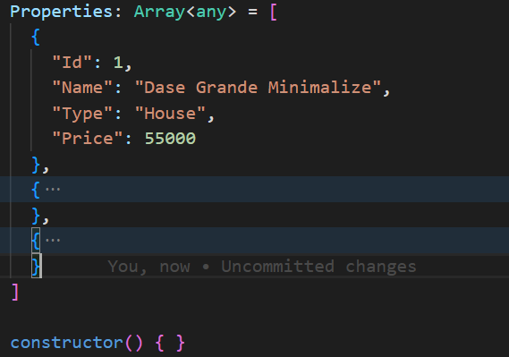

Step 2, Open property-card.component.ts and create Input decorators. It use for sharing data between child and parent. In this case “PropertyCard” is child component

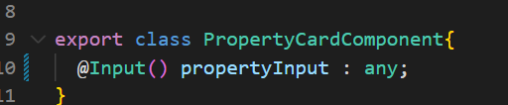

Step 3, Open app.component.html, then call property list selector. The question is where is the property card component? Why we don’t call it?

As per our requirement, property-card is a child, and property-list is a parent. We will call card inside the list property

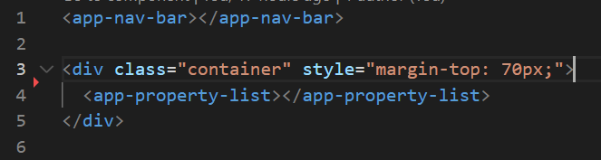

Step 4, Open property-list.component.html

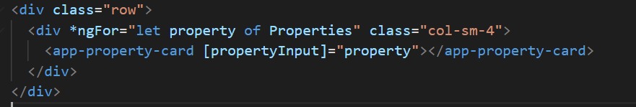

|  |
| --- |
| - Here we call property-card selector as child component  - ngFor is Directive Structural  - [propertyInput] is input decorator that defined by child component  - property is a object value  - Assignment [propertyInput] with property is called as Property Binding |

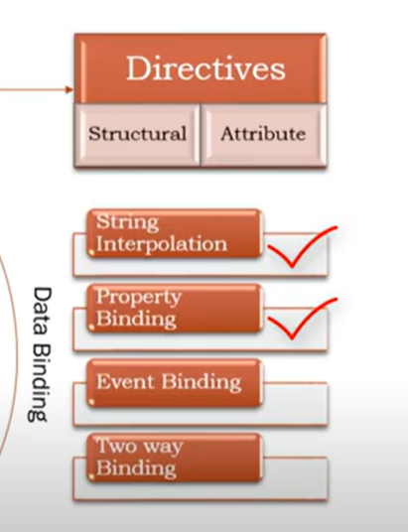

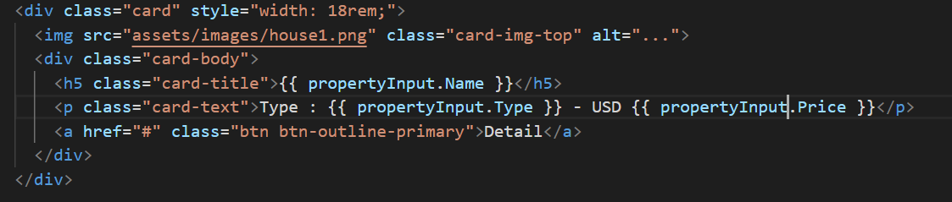

Finally you can open property-card.component.html, and modify like the above image

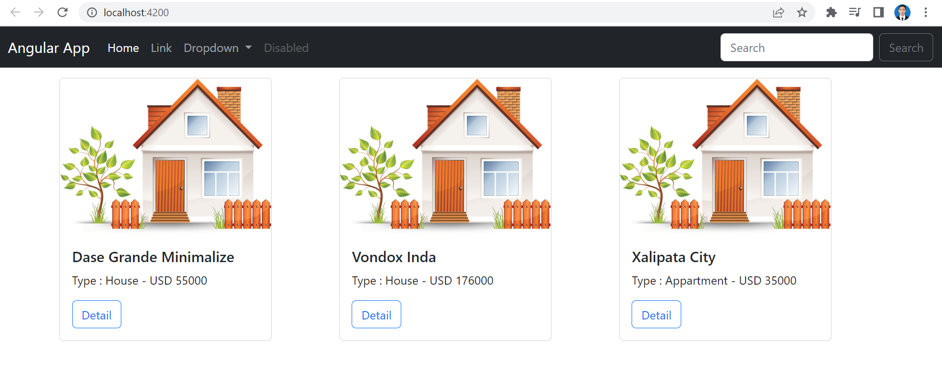

Reference :

<https://www.youtube.com/watch?v=z0O6qVEfOZc&list=PL_NVFNExoAxclqXo9fLAeP0G2Qp56Fu8C&index=8>

<https://www.youtube.com/watch?v=Y7Blm87AfW8&list=PL_NVFNExoAxclqXo9fLAeP0G2Qp56Fu8C&index=9>